Capstone Project Phase B

**Graph-Based Comparative Analysis of fNIRS Hyperscanning**

25-1-R-22

Author: Sara Saleh   
Supervisor: Dr. Anat Dahan

Table of Contents

**General Description** ............................................................................................................... **4**

**Solution Description** ............................................................................................................... **4**

**Target Users** ............................................................................................................................ **6**

**Development Process and Toolchain** ......................................................................................**6**

**Dataset Description………………….**.....................................................................................**8**

**Code Architecture and Implementation Details** .................................................................. **9**

Data Preparation and Preprocessing ............................................................................. 9

Intra-Brain Connectivity and Graph Construction ..................................................... 10

Graph-Based Analysis – Comparative Modules ......................................................... 11

Local Graph Analysis – Node-Level Connectivity .................................................... 12

Outputs and Visual Integration ................................................................................... 12

**Flow Diagram** ....................................................................................................................... **13**

**Graph Network Analysis** ..................................................................................................... **15**

Mean Degree by Condition and Role ......................................................................... 16

Clustering Coefficient by Condition and Role .......................................................... 16

Global Efficiency by Condition and Role .................................................................. 17

Small-Worldness by Condition and Role ................................................................... 18

Modularity by Condition and Role ............................................................................ 19

Dyadic Symmetry – Absolute Differences ................................................................ 20

Correlation Between Global Graph Metrics .............................................................. 21

Global Measures: Baby vs Parent ............................................................................. 22

Local Measures: Local Strength Difference per Node .............................................. 23

Local Strength – ‘Elicit’ Condition ............................................................................ 24

Local Strength – ‘Free’ Condition ............................................................................. 25

Local Strength – ‘Instruct’ Condition ........................................................................ 26

**User Guide** ............................................................................................................................. **27**

**Maintenance Guide** .............................................................................................................. **32**

**Technical Challenges and Solutions** .................................................................................... **34**

**Results and Conclusions** ...................................................................................................... **35**

**Graph Topology and Centrality Insights** ........................................................................... **36**

**Methodological Reflections** .................................................................................................. **36**

**Scientific Contributions** ....................................................................................................... **37**

**Lessons Learned** ................................................................................................................... **37**

**Success Metrics and Evaluation** .......................................................................................... **38**

**References** ............................................................................................................................. **40**

General Description

The project presents a research-driven computational framework designed to analyze functional brain connectivity in parent–infant dyads using fNIRS hyperscanning data and graph-theoretical metrics. This system was developed to facilitate the exploration of neural synchrony and brain network organization during various social interaction conditions, including free play, elicited interaction, and instructed tasks.

At its core, the system ingests multi-subject hemodynamic recordings and performs a structured pipeline of data processing, including:

* Construction of intra-brain correlation matrices for each participant (baby and parent) using Pearson’s correlation.
* Thresholding based on statistical significance and signal strength to generate binary adjacency matrices.
* Graph generation via NetworkX and extraction of both global metrics (e.g., mean degree, global efficiency, modularity, small-worldness) and local node-specific measures (e.g., strength per node).
* Comparative statistical analysis across conditions, participants, and brain regions.

A major component of the system is its interactive HTML dashboard, which enables researchers to intuitively explore visualizations of graph metrics, identify central brain nodes, observe condition-dependent connectivity patterns, and review dyadic symmetry and metric correlations. Each plot is accompanied by descriptive summaries and scientific interpretations, supporting transparent data communication and insight discovery.

The solution emphasizes modularity, reproducibility, and interpretability traits that are essential for rigorous cognitive neuroscience research.

It is implemented entirely in Python, leveraging libraries such as pandas, numpy, networkx, and matplotlib, and is structured to accommodate additional experimental conditions or new types of metrics in the future.

Solution Description

The solution developed in this research project is a structured, data-driven framework for quantifying intra-brain functional connectivity in parent–infant dyads using fNIRS hyperscanning data. Unlike traditional approaches that focus on behavioral synchronization or inter-brain metrics, this system provides a detailed account of each participant’s own brain connectivity across different types of social interaction.

At the heart of the framework lies a modular pipeline, implemented in Python, that transforms raw hemodynamic signals into interpretable graph-based representations. The process begins with the conversion of .mat files - containing multi-channel fNIRS time-series data - into standardized .csv tables through a dedicated script (convert_mat_to_csv.py). These CSV files, each representing a single participant in a given condition, are normalized and relabeled to ensure consistent naming conventions and to correct for common formatting errors (normalize_and_copy_csv.py).

From there, the system computes intra-brain Pearson correlation matrices for each participant, resulting in symmetric 18×18 connectivity matrices where each cell quantifies the statistical association between a pair of cortical channels (intra_brain_connectivity.py). These matrices are thresholded by both statistical significance (p ≤ 0.05) and effect size (|r| ≥ 0.3), producing sparse adjacency matrices that reflect only the most reliable intra-brain connections. Each resulting adjacency matrix is used to construct an undirected brain network, visualized as a graph and stored alongside the numeric data for interpretability.

The second layer of the system performs graph-theoretical analysis to extract both global and local network metrics (extract_intra_measures.py). These include:

Global measures such as mean degree, global efficiency, modularity, small-worldness, and mean clustering coefficient - each summarizing the structural integrity of the brain network.

Local node-specific measures, primarily node strength, which captures the cumulative connectivity of each brain region.

To support scientific exploration, several comparative scripts were implemented to analyze trends across dyads and experimental conditions. For example, compare_strength_by_condition.py aggregates node strength per condition and role, producing condition-specific barplots. Meanwhile, compare_strength_by_dyad.py computes the average difference in node strength between babies and parents across all dyads, enabling identification of systematic regional differences. Additional modules compare global metrics across conditions (compare_conditions.py), examine role-specific trends (compare_roles_by_dyad.py), quantify intra-dyad metric symmetry (compare_dyadic_symmetry.py), and explore the correlations between network metrics themselves (compare_metric_correlations.py).

All outputs are collected in structured CSV reports and summarized graphically in a custom-built HTML dashboard, allowing researchers to explore results interactively without writing code.

The architecture is designed for clarity, reproducibility, and scientific rigor. Every step -from raw data handling to high-level network analysis - adheres to best practices in both neuroscience and software engineering. Moreover, by focusing on intra-brain topology , this approach allows researchers to track how individual brain networks evolve in response to different interaction contexts, shedding light on the developmental and cognitive aspects of parent–infant social behavior.

Target Users

The intended audience for this system includes:

* **Neuroscientists and developmental** psychologists investigating functional connectivity, especially within the context of early social interaction.
* **Graduate students and academic researchers** seeking intuitive, yet methodologically rigorous, tools for hyperscanning data analysis.
* **Data scientists and interdisciplinary teams** working at the intersection of neuroscience, education, and social cognition.

By lowering the barrier to entry for advanced graph-based analyses, this framework empowers researchers to pose deeper questions about human connection, neural development, and the structure of social interaction from a network perspective.

Development Process and Toolchain

The development process followed an iterative cycle of design, implementation, and refinement. At the outset, we reviewed relevant literature in developmental cognitive neuroscience to guide the structure and analytical focus of the system. Prior studies have emphasized the importance of brain regions such as the prefrontal cortex (PFC) and temporo-parietal junction (TPJ) in social processes like mentalizing, empathy, and joint attention in early interactions between parents and children [5], [7].

The fNIRS dataset used in this project was provided by our course supervisor, Dr Anat Dahan, as part of a prior developmental hyperscanning study. The data includes simultaneous fNIRS recordings from approximately 20 parent–infant dyads engaged in naturalistic tasks such as free play and elicited interaction. Each participant was recorded using a dual-headset configuration, yielding separate fNIRS time-series for parent and infant, covering multiple cortical regions - including frontal and temporoparietal areas - as defined by the original researchers’ acquisition protocol.

# Importantly, the dataset was already preprocessed prior to our work. We did not perform raw signal cleaning, filtering, or hemoglobin conversion ourselves. Instead, we worked with data that had already undergone standard preprocessing steps, such as band-pass filtering and the application of the modified Beer–Lambert law, to produce time-series reflecting changes in oxygenated hemoglobin concentration per channel.

# Our development work focused on the analytical pipeline:

# First, we converted the .mat-format recordings to standardized .csv tables using custom Python scripts. Each file represented one participant in one condition, with rows corresponding to time points and columns to fNIRS channels. We then applied normalization and filename correction routines to ensure all datasets followed a consistent structure across dyads and conditions.

# We used these time-series to compute intra-brain Pearson correlation matrices for each individual, capturing the statistical associations between all pairs of brain regions (channels). These matrices were thresholded by both correlation magnitude (|r| ≥ 0.3) and significance (p ≤ 0.05), yielding binary adjacency matrices that describe the presence or absence of within-brain functional connections. These were then transformed into undirected graphs using the networkx library.

# From these graphs, we extracted both global and local graph-theoretical measures. Global metrics included:

* + Degree (node connectivity): Number of edges connected to a node, indicating how central a brain region is.
  + Clustering Coefficient (local grouping): Measures the tendency of a node's neighbors to form connections, reflecting local connectivity.
  + Path Length (shortest connections): The shortest path between two nodes, used to assess network efficiency.
  + Global Efficiency (information flow): Reflects how efficiently information is integrated across the entire network.
  + Modularity (community detection): Indicates the presence of distinct communities or modules within the network.
  + Small-Worldness: Describes networks that balance high local clustering with short path lengths, characteristic of efficient brain networks.

By applying these graph measures, researchers can study how functional brain networks change during social interaction, collaboration, or other shared activities in hyperscanning studies. For instance, they can investigate whether inter-brain connectivity increases during cooperative tasks or how network efficiency evolves under different conditions. This graph-based analysis provides a systematic way to interpret complex fNIRS data and gain insights into the neural mechanisms underlying individual and shared cognitive processes.

Local analyses focused on node strength, calculated per channel, to identify which brain regions showed stronger or weaker intra-brain connectivity under different conditions.

# We implemented several dedicated Python modules to perform comparative analysis across roles (baby vs. parent), interaction conditions (free, elicit, instruct), and dyads. These included:

# Role-based comparisons of graph metrics,

# Condition-wise differences in node strength,

# Dyadic asymmetry analysis,

# and correlation heatmaps of network measures.

# All data outputs were exported into structured CSV files and visualized via a custom HTML dashboard, allowing for intuitive toggling between dyads, roles, and conditions.

# Development was carried out using a rich ecosystem of Python tools including numpy, pandas, matplotlib, seaborn, and networkx. The system architecture was designed for modularity and reproducibility, enabling separate testing of each component and facilitating future extensions.

# Unlike some studies that incorporate random-pair permutation tests to rule out spurious synchrony across individuals, our project focused exclusively on intra-brain connectivity. The pipeline does not include simulations or shuffled dyads, as the goal was not to test inter-brain coupling but rather to characterize the internal structure of each participant’s brain network across social conditions.

Dataset Description

The dataset used in this study was provided by our course supervisor and originates from a developmental fNIRS hyperscanning paradigm. It comprises recordings from 19 parent–infant dyads, each participating in three social interaction conditions: Free, Elicit, and Instruct. For each dyad and condition, separate fNIRS recordings were collected for the parent and the infant, yielding a total of 114 individual .mat files.

Each recording is structured as a matrix of 1892 time points × 18 channels, where each column represents an fNIRS signal from a distinct cortical location, and each row represents a time sample. The signals reflect preprocessed measurements of oxygenated hemoglobin concentration (HbO), prepared in advance by the data providers.

Thus, the dataset spans a rich set of within-brain time-series for both roles (parent and infant), across varied interaction scenarios, and enables systematic investigation of intra-brain connectivity using graph-theoretical approaches

# Code Architecture and Implementation Details

## Data Preparation and Preprocessing

* 1. **MATLAB to CSV Conversion**

The first step in our fNIRS analysis pipeline is the transformation of raw data from MATLAB .mat files into clean .csv format. This is critical for integrating the data into our Python-based processing framework.

Functionality:

* Loads raw .mat files containing parent and infant time-series recordings.
* Extracts relevant hemoglobin signals (e.g., HbO) across 18 channels per participant.
* Converts each time-series into tabular form (time x channel) and writes to .csv.
* Ensures correct naming convention (dyad, condition, role).

This conversion enables seamless downstream computation and ensures compatibility across modules.

* 1. **CSV Cleaning and Normalization**

Once converted, the CSV files undergo standardization and normalization to ensure comparability.

Functionality:

* Cleans inconsistent data fields and aligns recording durations.
* Applies z-score normalization to each channel: (value - mean) / std.
* Produces uniformly formatted CSVs with consistent shape.

This step reduces inter-individual signal variation and ensures that correlation results reflect signal synchrony rather than absolute magnitudes.

## Intra-Brain Connectivity and Graph Construction

* 1. **Correlation Matrix Computation**

The next step calculates the intra-brain functional connectivity by computing correlation matrices.

**Script: intra_brain_connectivity.py**

Functionality:

* For each CSV, computes Pearson correlation between all 18 channels.
* Filters correlation values using dual threshold: |r| >= 0.3 and p-value <= 0.05.
* Saves 18x18 matrix per participant as .csv.
  1. **Adjacency Graph Construction and Metric Extraction**

**Script: extract_intra_measures.py**

Functionality:

* Loads correlation matrices.
* Constructs binary adjacency matrices (edges = strong correlation).
* Builds undirected graphs using networkx.
* Extracts metrics:
* **Global:** Mean Degree, Global Efficiency, Clustering Coefficient, Modularity, Small-Worldness.
* **Local:** Node Strength per channel.
* Saves results into structured CSV:

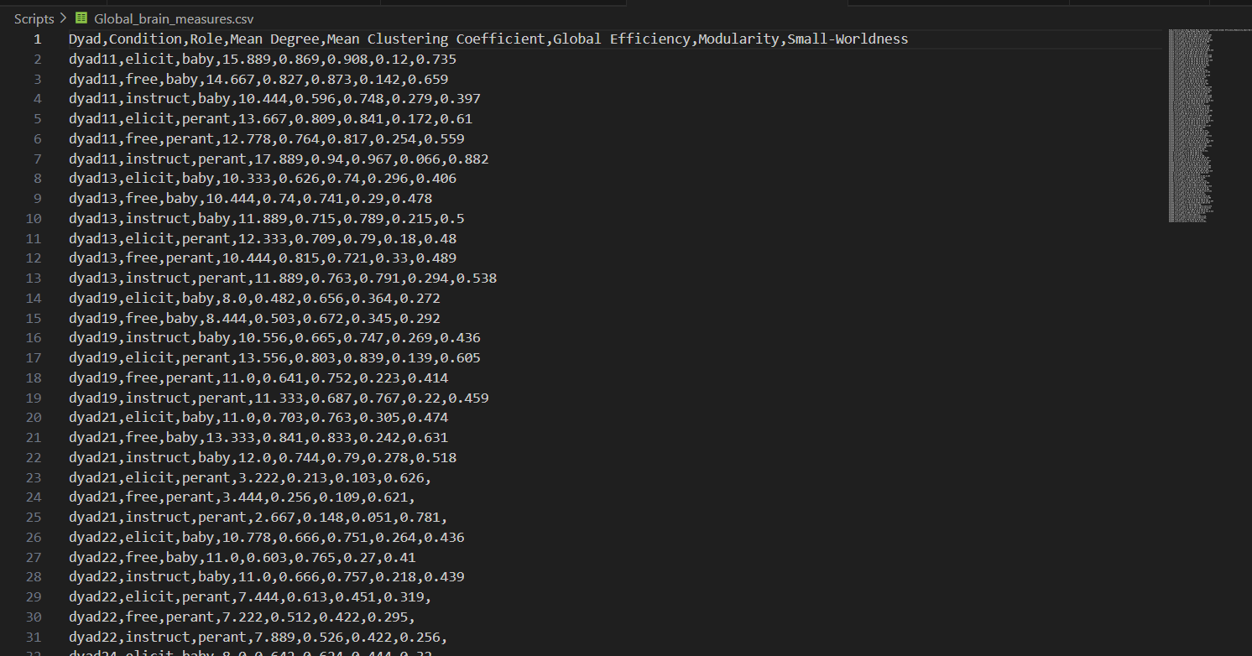

## Graph-Based Analysis – Comparative Modules

All the following scripts are located in the analysis/ folder.

### **Comparing Global Metrics by Condition**

Script: compare_conditions.py

Functionality:

* Compares global metrics across the three experimental conditions: free, elicit, instruct.
* Generates bar plots for each metric.
* Outputs: CSV summary + PNG plots (will be shown in the final dashboard).

**3.2 Dyadic Symmetry Analysis**

**Script:** compare_dyadic_symmetry.py

Functionality**:**

* Calculates average metric difference (absolute) between parent and infant within each dyad.
* Visualizes per-metric asymmetry via bar plot.
* Outputs: CSV summary + PNG plot.

**3.3 Correlation Between Metrics**

**Script:** compare_metric_correlations.py

Functionality:

* Computes Pearson correlation matrix across all global metrics.
* Visualizes heatmap of inter-metric relationships.
* Outputs: Correlation matrix CSV + heatmap PNG.

### **3.4 Role-Based Comparison per Dyad**

**Script:** compare_roles_by_dyad.py

Functionality:

* For each dyad, compares global metrics between parent and infant.
* Aggregates which role had a higher value per metric.
* Outputs: Summary CSV + visualization.

1. Local Graph Analysis – Node-Level Connectivity

All the following scripts are located in the local_analysis/ folder.

### **4.1 Strength Difference per Node (Average Across Dyads)**

**Script:** compare_strength_dyadic_difference.py

Functionality:

* Calculates mean difference (baby - parent) in node strength per channel.
* Outputs: CSV + node-wise bar plot.

**4.2 Strength Profiles by Condition**

**Script:** compare_strength_by_condition.py

Functionality:

* For each condition, aggregates average node strength per role.
* Generates separate plots for free, elicit, instruct.
* Outputs: CSV per condition + visual plots.

1. Outputs and Visual Integration

All plots and results are compiled into an interactive HTML dashboard, which allows users to:

* Browse graph comparisons by dropdown selection.
* View visualizations and their explanations.
* Read brief conclusions per plot.

Additionally, metric summary tables (global and local) are embedded in the dashboard using iframe referencing exported HTML reports.

All visual outputs are stored under visualizations/ and all summary tables in tables/.

# Flow Diagram

* 1. **Location** : **FinalProject_Sara/Scripts folder:**
  2. **Location: FinalProject_Sara/analysis folder:**
  3. **Location: FinalProject_Sara/Local_Analysis folder:**
  4. **Dashboard for visualizing graphs and tables**

**Location: FinalProject_Sara/index.html**

Graph Network Analysis:

In this section, we present a graph-theoretical analysis of intra-brain connectivity in infants and parents, derived from fNIRS hyperscanning data collected during naturalistic social interaction. Each participant’s brain is modeled as a network, where nodes represent cortical regions (fNIRS channels), and edges represent statistically significant functional connections between them. By applying metrics such as mean degree, global efficiency, modularity, clustering coefficient, and small-worldness, we quantify the organizational properties of these networks.

This approach allows us to capture the balance between local specialization and global integration in the developing brain, providing insights into how infants’ brain connectivity compares to that of adults under different interaction conditions (Free, Elicit, Instruct). The results below offer a condition- and role-specific breakdown of graph measures, accompanied by interpretations grounded in developmental neuroscience theory.

1. **Mean Degree by Condition and Role**

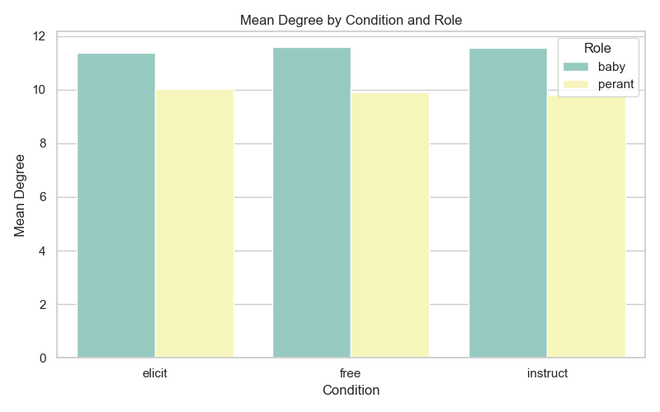

The **mean degree** metric, which quantifies the average number of connections per brain region, reflects the overall density of functional connectivity within the network. In our analysis, infant brains consistently exhibited higher mean degree values compared to parents across all interaction conditions (e.g., approximately 11.5 vs. 10.5), suggesting a more densely interconnected neural architecture. This pattern is consistent with known developmental phenomena such as synaptogenesis during early life, which promotes widespread connectivity across cortical regions. In contrast, the lower mean degree observed in parents likely reflects the effects of synaptic pruning and increasing functional specialization, which streamline the network by reinforcing essential pathways while eliminating redundant connections [16,14].

1. **Clustering Coefficient by Condition and Role**

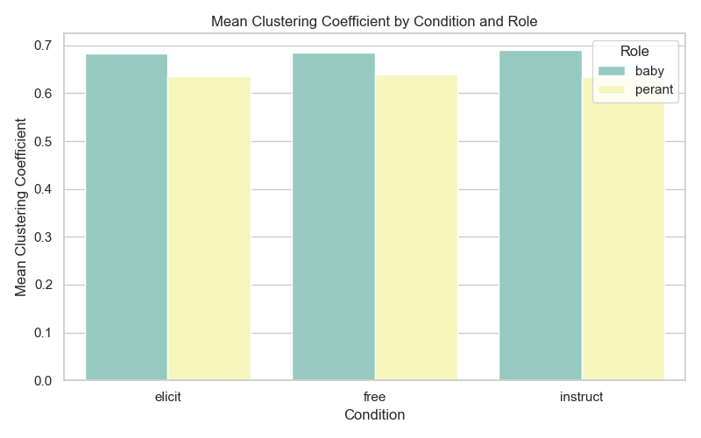

The **clustering coefficient** captures the density of local connectivity by quantifying how interconnected a node’s immediate neighbors are. High clustering values are indicative of tightly knit local communities, a hallmark of modular neural networks [15]. In our analysis, infant brains consistently exhibited slightly higher clustering coefficients compared to parents (e.g., ~0.67 vs. ~0.62), suggesting stronger local connectivity. This observation aligns with developmental expectations: in early life, synaptic exuberance leads to denser local interconnections due to minimal pruning. In contrast, the lower clustering in parents reflects more selective and functionally refined local organization, where synapses are retained primarily in behaviorally and cognitively relevant subnetworks [11,12].

1. **Global Efficiency by Condition and Role**

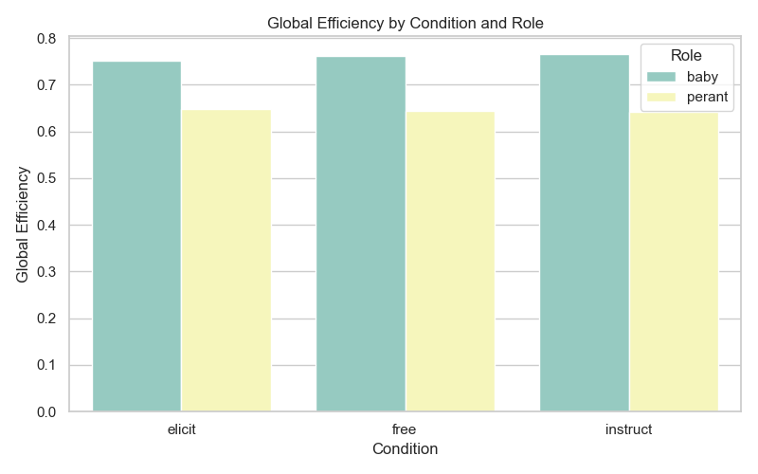

**Global efficiency** reflects the brain network’s capacity for rapid and integrated information transfer, calculated as the inverse of the average shortest path length between all node pairs [15]. While adult brains typically optimize efficiency within specialized modules, infant brains can sometimes exhibit even higher global efficiency, owing to more diffuse and abundant inter-regional connections during early development [13,16]. In our findings, infants consistently showed higher global efficiency across all interaction conditions—for example, approximately 0.75 compared to 0.65 in parents during the “Free” condition. This elevated efficiency suggests that infant brain networks are organized in a way that facilitates broad, rapid communication across regions, though with less specialization. By contrast, the lower efficiency in parent networks likely reflects more modular and functionally selective connectivity patterns, prioritizing targeted processing over general integration [13,16].

1. **Small-Worldness by Condition and Role**

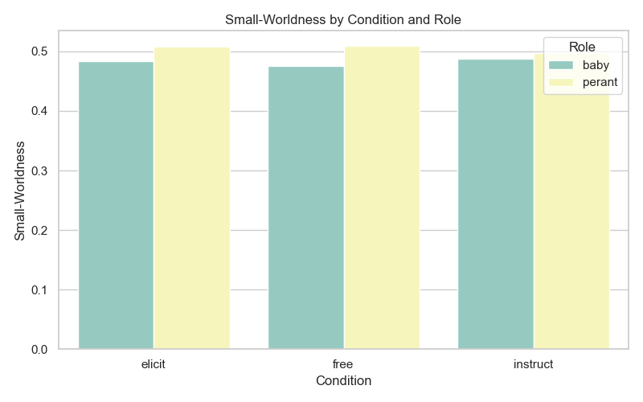

**Small-worldness** reflects a network’s ability to maintain both strong local clustering and short global path lengths—an architectural balance that supports efficient parallel and integrative information processing [10]. Although this property is typically more pronounced in mature adult brains, previous research has shown that even infant networks exhibit emerging small-world characteristics [11]. In our analysis, both infant and parent networks demonstrated small-worldness values in the range of 0.45–0.5, with parents consistently showing slightly higher scores—for instance, 0.50 versus 0.46 during the “Free” condition. While these absolute values fall below the classical benchmark threshold (>1), they nonetheless suggest a small-world configuration when contrasted with random networks. This finding indicates that both developing and mature brains preserve key small-world features. The marginally higher values observed in parents may point to a more finely tuned balance between integration and segregation, achieved through neural maturation and functional specialization [11,12].

1. **Modularity by Condition and Role**

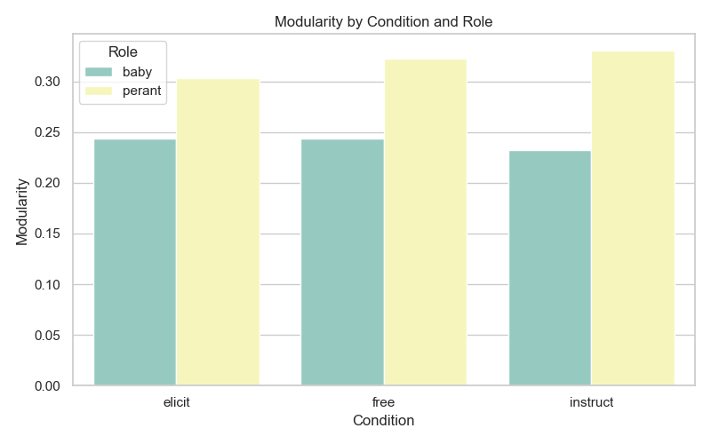

**Modularity** captures the extent to which a brain network is divided into distinct functional communities, with higher values indicating stronger community structure and greater functional segregation [15]. In adult brains, high modularity reflects the presence of well-defined systems—such as the visual, sensorimotor, and default-mode networks—that support specialized processing. By contrast, infant brains typically exhibit lower modularity early in development, reflecting a more integrative and less compartmentalized organization that evolves with age [13,14]. In our analysis, parent brain networks showed consistently higher modularity across all interaction conditions—for example, approximately 0.33 in parents versus 0.25 in infants—suggesting that infant neural architecture is less segregated. This reduced modularity aligns with known developmental processes, wherein synaptic pruning and functional specialization gradually sculpt the brain’s community structure over time [13,14].

1. **Dyadic Symmetry – Absolute Differences**

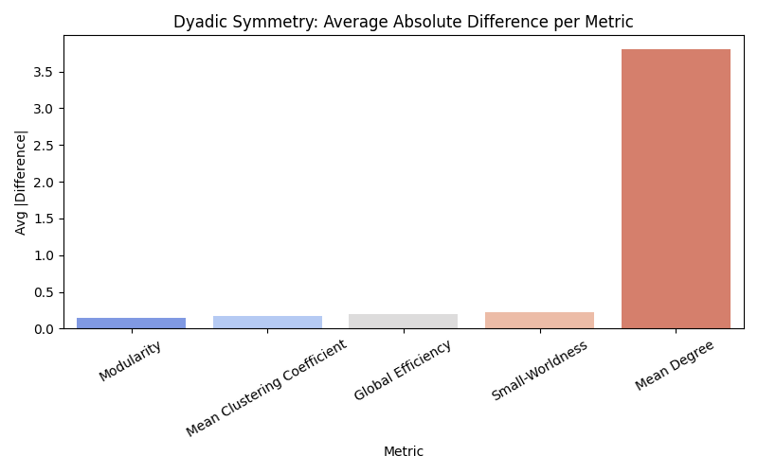

**Dyadic symmetry** captures the degree of similarity between parent and infant brain networks by comparing global graph metrics within each dyad. We assessed this by calculating the average absolute difference in five key measures: modularity, mean clustering coefficient, global efficiency, small-worldness, and mean degree [1]. Lower differences reflect stronger symmetry, indicating comparable network organization between the two brains. In our findings, nearly all metrics- except for mean degree- showed minimal differences across dyads, suggesting a high degree of structural alignment in terms of modularity, clustering, efficiency, and small-world characteristics. The one exception was mean degree, which displayed a noticeably larger gap, indicating that infants typically possess more connections per brain region than their parents. This elevated connectivity density in infants aligns with the well-established phenomenon of synaptic exuberance during early development [13,14]. Together, these results suggest that even at an early developmental stage, infant brains already reflect adult-like topological organization, supporting the notion of neural attunement during social interaction. The observed symmetry may facilitate efficient information exchange between parent and infant-a capacity that could be foundational for early social and cognitive development [5,6,11].

1. **Correlation Between Global Graph Metrics**

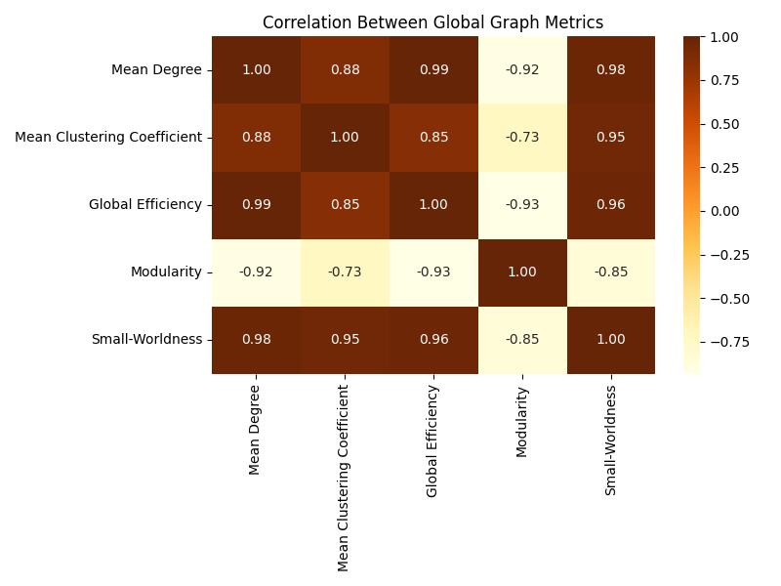

The heatmap illustrates the Pearson correlation coefficients computed between pairs of global graph metrics, combining data from both infants and parents across all interaction conditions. Each cell represents the strength and direction of the linear relationship between two metrics: warmer colors indicate strong positive correlations, while cooler shades signal negative associations. This analysis reveals how various aspects of brain network topology tend to co-vary, indicating either functional coupling or theoretical trade-offs between properties.

The results highlight a remarkably strong positive correlation among **Mean Degree**, **Global Efficiency**, and **Small-Worldness**. For example, the correlation between Degree and Efficiency is nearly perfect (r ≈ 0.99), and both show similarly high correlations with Small-Worldness (r ≈ 0.95–0.98). This suggests that brain networks with a greater number of connections per region are also more efficient in information transfer and exhibit stronger small-world structure. The **Mean Clustering Coefficient** also demonstrates moderate-to-strong positive associations with these metrics (e.g., r ≈ 0.85 with Efficiency), indicating that networks with dense local connectivity tend to also support efficient global communication and maintain small-world characteristics.

In contrast, **Modularity** shows a strong inverse relationship with most other metrics. Its negative correlations with Degree, Efficiency, and Small-Worldness (r ≈ –0.85 to –0.93) suggest that highly connected and integrated networks tend to be less segregated into distinct modules. This reflects a known trade-off in complex network theory: increased functional integration often comes at the cost of reduced modular specialization [9], [15]. Even Clustering Coefficient displays a milder negative association with Modularity, reinforcing the notion that local cohesion can also reduce the network’s tendency to separate into discrete communities.

Altogether, this correlation matrix confirms that global graph metrics are not independent descriptors. Instead, they follow coherent patterns that align with theoretical principles of brain network organization. Dense and efficient networks (with high Degree and Efficiency) tend to be less modular but maintain strong small-world properties—balancing local specialization and global integration. These findings echo established models in developmental neuroscience, where the maturing brain dynamically optimizes between integration and segregation, shaping its network toward functional efficiency without completely sacrificing modular organization [10], [13], [14].

1. **Global Measures: Baby vs Parent (Dyadic Summary)**

This bar chart offers a direct comparison between parents and infants across several global graph metrics, indicating which member of each dyad tends to exhibit higher values. For every metric, two bars are presented: one representing the number of dyads in which the infant had a higher value, and the other representing cases where the parent had the higher score. This visualization highlights consistent patterns of difference between developmental stages in terms of brain network organization.

The results reveal systematic distinctions. For Mean Degree, the majority of dyads show higher values in infants, suggesting that infant brain networks typically include more functional connections per region than those of their parents. A similar trend is observed in Global Efficiency and Clustering Coefficient, where infants more frequently exhibit higher scores. These findings suggest that infant networks tend to be both more globally integrated and more locally clustered, which may reflect early-stage synaptic exuberance and diffuse connectivity characteristic of developing brains [11], [13].

In contrast, the metric of Modularity tells a different story: most dyads show higher values in parents, indicating that adult brain networks are more strongly organized into segregated communities. This pattern reflects a developmental shift toward functional specialization, in which cortical regions become more selectively interconnected over time. Interestingly, the Small-Worldness measure displays a relatively balanced distribution, with no consistent advantage to either infants or parents, implying that both groups achieve small-world characteristics in roughly equal proportions.

Altogether, these findings point to a developmental contrast in brain network topology. Infants tend to exhibit highly connected, integrated, and clustered networks, while adults more often present with modular, functionally segregated architectures. This pattern aligns with established models of neural maturation, where early networks are broadly interconnected and gradually evolve into more modular and specialized systems as cognitive functions mature [11], [13], [14], [20].

1. **Local Measures: Local Strength Difference per Node (Baby – Parent)**

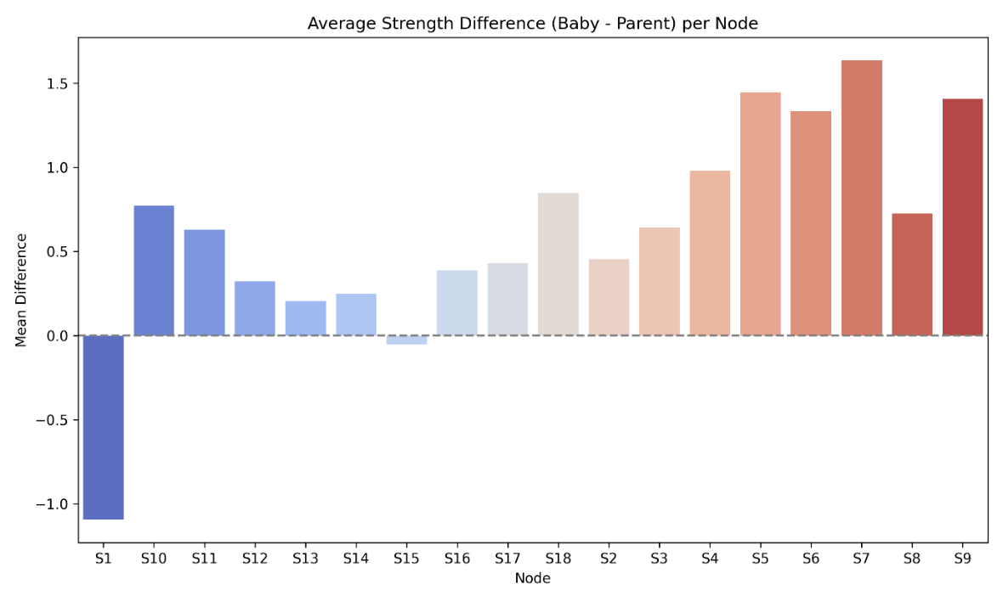

This analysis focuses on local network strength differences across cortical regions, comparing infants and their parents on a node-by-node basis. Node strength is defined as the sum of all functional connection weights for a given node, capturing how strongly that specific brain region is connected to the rest of the intra-brain network. For each corresponding pair of nodes (S1 to S18) in the parent and infant, we computed the difference in strength (infant minus parent) and averaged this across all dyads. The results are visualized as a bar chart, with each bar representing the mean strength difference for a specific channel. Positive values indicate higher strength in infants, whereas negative values indicate higher strength in parents.

The findings reveal a striking trend: the majority of nodes show positive differences, meaning infants tend to have higher connectivity strength than their parents in most brain regions recorded. In particular, nodes such as S3 and S5 through S9 exhibit noticeably stronger connectivity in infants, suggesting these regions may serve as functional hubs in the infant brain. Although many bars are small in magnitude, the overall pattern clearly favors higher infant strength. Only one node, S2, shows a negative difference, where parents on average exhibit slightly greater strength.

These results highlight a widespread developmental pattern: infants display globally elevated intra-brain functional connectivity strength across the measured prefrontal cortex. This is consistent with theoretical and empirical work suggesting hyperconnectivity in infancy- a phase of high synaptic density and widespread activation that becomes more specialized and pruned over time [11], [12], [14], [20]. The dominance of infant-over-parent differences across almost all nodes aligns with expectations from developmental neuroscience, underscoring the early brain’s diffuse and richly connected nature prior to maturation-driven refinement.

1. **Local Measures: Node Strength under 'Elicit' Condition**

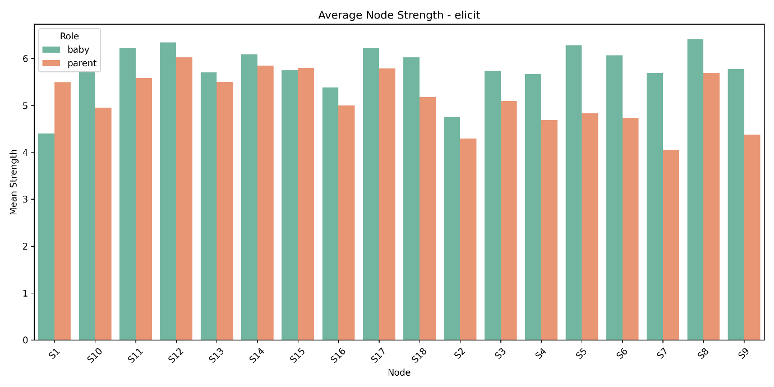

This graph presents the average node strength for infants and parents under the Elicit condition, which corresponds to structured social interaction. Node strength in this context reflects the sum of all functional connection weights associated with a given brain region, effectively quantifying how strongly each node participates in intra-brain connectivity.

The results indicate that most cortical regions (S1 through S18) exhibit higher average strength in infants compared to their parents. Notably, S5, S7, and S9 stand out with the most pronounced differences, suggesting these regions are especially active or centrally connected during elicitation tasks. The only exception is S2, where parents slightly exceed infants in node strength—replicating a pattern observed in other parts of the analysis.

These findings suggest that during elicited interactions, infant brains show broader and more diffuse neural engagement across prefrontal areas. This observation supports previous hyperscanning research, which has shown that infants tend to recruit widespread cortical networks when involved in rich, socially structured tasks [21]. The elevated node strength in infants likely reflects a developmental stage marked by synaptic overconnectivity and reduced specialization—enabling generalized processing during social interaction before later pruning and functional refinement.

1. **Local Measures: Node Strength under 'Free' Condition**

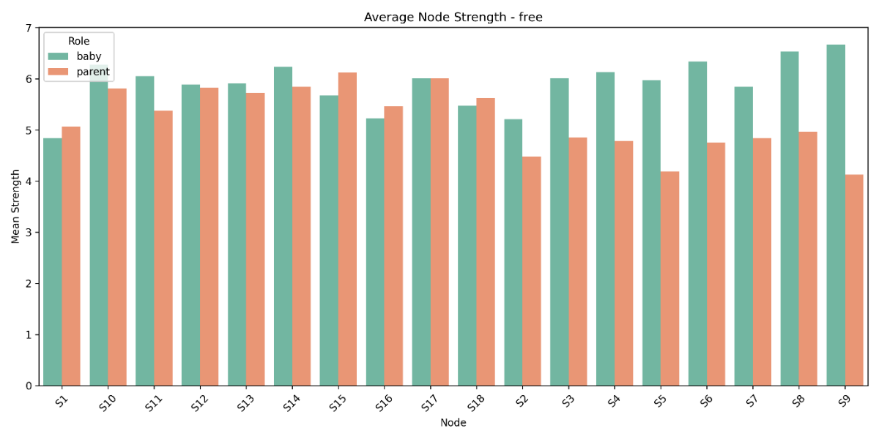

This graph illustrates local node strength values under the Free condition, during which parents and infants engage in unstructured play that allows for spontaneous, self-directed social behavior. As in the Elicit condition, infants consistently exhibit higher node strength across the majority of cortical regions, indicating a widespread pattern of elevated intra-brain connectivity.

Although the overall strength values are slightly reduced in comparison to the Elicit condition, the same regions- such as S7 and S9-continue to show relatively high activation in both groups. The reduction in absolute values suggests a marginal decrease in the intensity of neural engagement, which is expected in the absence of structured prompts. However, the overall pattern of higher connectivity in infants remains clear and consistent.

These findings point to an important developmental feature: infants display strong functional connectivity even in the absence of external social cues, indicating an intrinsic neural readiness for interaction. This sustained frontal connectivity during free-play aligns with previous developmental research suggesting that early social cognition is supported by internally driven neural mechanisms that are already active in unstructured contexts [5], [6].

1. **Local Measures: Node Strength under 'Instruct' Condition**

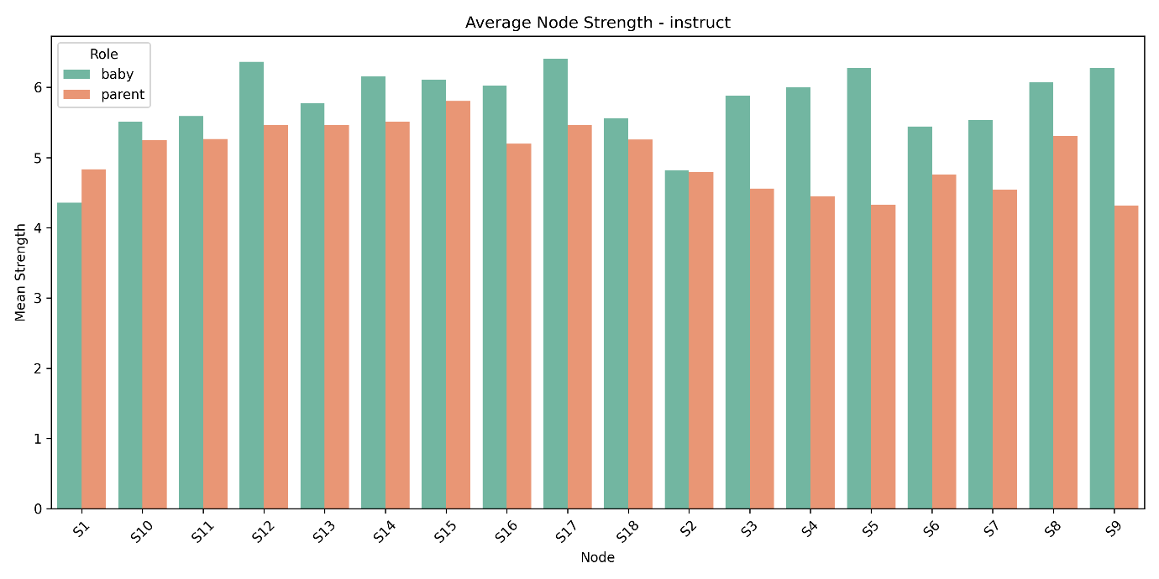

This graph presents the local node strength comparison between infants and parents under the Instruct condition, which involved structured, guided interaction. As observed in the previous conditions, infants again demonstrate higher average node strength across nearly all brain regions measured. The most pronounced differences appear in channels S5, S7, and S9, where infant connectivity significantly exceeds that of their parents. Notably, S2 once again emerges as the only region where parents show slightly higher strength, replicating a consistent trend observed across conditions.

These results indicate that even in directive, structured interactions, infant brains remain broadly and robustly engaged, activating widespread networks throughout the prefrontal cortex. This reinforces the conclusion that infants consistently recruit diffuse neural resources across all interaction types—whether spontaneous or guided. Such a pattern aligns with well-established developmental neuroscience literature, which describes early brain function as characterized by widespread connectivity and limited specialization, gradually transitioning into more modular and efficient networks with maturation [13], [14].

User Guide

**Purpose**

This guide provides a step-by-step operational manual for using the graph-based analysis system designed for analyzing fNIRS hyperscanning data of parent–infant dyads. It walks the user through the full processing pipeline, from raw .mat files to interactive HTML visualizations, as implemented in the FinalProject_Sara system.

**System Overview**

The system processes dual-subject fNIRS data, constructs intra- and inter-brain connectivity graphs, extracts graph metrics, and displays interactive plots and metric tables for comparison across roles (parent vs. infant) and conditions (free, elicit, instruct).

FinalProject_Sara/

**Folder Structure**

├Scripts/ # Main pipeline scripts

├analysis/ # Global graph comparison scripts

├ Local_Analysis/ # Node-level strength analysis scripts

├ finalproject_records/ # CSV summary tables

├ index.html # Interactive dashboard (final report)

**Nominal Operational Flow**

**1. Convert MATLAB .mat Files to CSV**

* **Script**: convert_mat_to_csv.py
* **Action**: Converts raw fNIRS .mat recordings into standardized CSV files (per role & condition).
* **Input**: MATLAB .mat files
* **Output**: Cleaned CSVs in the format: DyadID_Role_Condition.csv

**2. Clean and Normalize CSV Files**

* **Script**: clean_and_normalize_csv.py
* **Action**: Aligns durations and normalizes each channel’s signal using z-scoring.
* **Input**: Raw CSVs
* **Output**: Standardized and normalized CSV files, ready for correlation analysis.

**3. Compute Intra-Brain Correlation Matrices**

* **Script**: intra_brain_connectivity.py
* **Action**: Computes Pearson correlation (with thresholding: |r| ≥ 0.3 and p ≤ 0.05) for each participant's channels.
* **Output**: 18×18 correlation matrices per participant.

**4. Extract Intra-Brain Graph Metrics**

* **Script**: extract_intra_measures.py
* **Action**: Converts correlation matrices into binary adjacency graphs, computes:
  + Global metrics: Mean Degree, Efficiency, Modularity, Clustering, Small-Worldness
  + Local metrics: Node Strength
* **Output**: CSVs per dyad with intra-brain metrics.

**5. Compare Global Metrics by Condition**

* **Script**: compare_conditions.py (in analysis/)
* **Action**: Generates bar plots for each global metric across:  
  free, elicit, instruct.
* **Output**: PNG plots + summary CSVs.

**6. Dyadic Symmetry Analysis**

* **Script**: compare_dyadic_symmetry.py
* **Action**: Computes average absolute differences between parent and infant on each metric.
* **Output**: Symmetry plots and tables.

**7. Correlation Between Metrics**

* **Script**: compare_metric_correlations.py
* **Action**: Generates heatmap of correlations among global metrics.
* **Output**: Heatmap PNG + correlation matrix CSV.

**8. Role-Based Comparison**

* **Script**: compare_roles_by_dyad.py
* **Action**: Determines for each metric whether baby or parent has higher value in each dyad.
* **Output**: Bar chart PNG + summary CSV.

**9. Node-Level Strength Analyses**

Located in the local_analysis/ folder.

**A. Strength Difference (Baby – Parent)**

* **Script**: compare_strength_dyadic_difference.py
* **Output**: Node-by-node bar plot and CSV of average differences.

**B. Strength by Condition**

* **Script**: compare_strength_by_condition.py
* **Output**: Separate plots (PNG) for each condition and role + CSVs.

**10. Generate Final HTML Dashboard**

* **File**: index.html
* **Action**: Aggregates:
  + All plots and visualizations (from visualizations/)
  + All metric tables (from tables/)
  + Includes explanatory text, dropdown filters, and interactive graph views.
* **Usage**: Open in browser to navigate through dyads, conditions, and metric summaries.

**11. Using the Interactive HTML Dashboard**

File: index.html  
Location: Root directory of the project (FinalProject_Sara/)

After running the full pipeline, open the index.html file in a web browser to access the interactive dashboard. This dashboard offers a clean and intuitive way to explore all graph-theoretical results across dyads, roles, and conditions.

Interface Features:

**Section Type Dropdown (Left):**  
This menu allows users to select the type of analysis or visualization they want to explore. The available sections include:

* Global Measures – By Condition:  
  Compare each global metric (e.g., Degree, Efficiency) across the three conditions: Free, Elicit, Instruct.
* Global Measures – Baby vs Parent:  
  Compare average global metric values between roles across all dyads.
* Global Measures – Dyadic Symmetry:  
  Visualize the absolute difference in metrics between parent and infant in each dyad.
* Global Measures – Correlation Between Metrics:  
  Shows inter-metric relationships via a correlation heatmap.
* Local Measures – Local Strength Difference:  
  Displays node-by-node strength differences (baby minus parent).
* Local Measures – Local Strength by Condition:  
  Presents average node strength values per role, per condition.
* Global Table View:  
  Full metric summary table across all dyads.
* Local Table View:  
  Node strength table across all conditions and roles.

**Select Graph Dropdown (Right):**  
Based on the section selected, this menu lists the corresponding graphs (e.g., mean_degree_barplot.png, modularity_barplot.png, etc.) so the user can choose the specific visualization to display.

Graph Output:

Once a graph is selected, it is rendered dynamically in the dashboard with:

* Title
* X/Y axes labeled
* Color-coded bars/heatmaps by role (baby/parent)
* Explanatory Description and Conclusion auto-filled below the image.

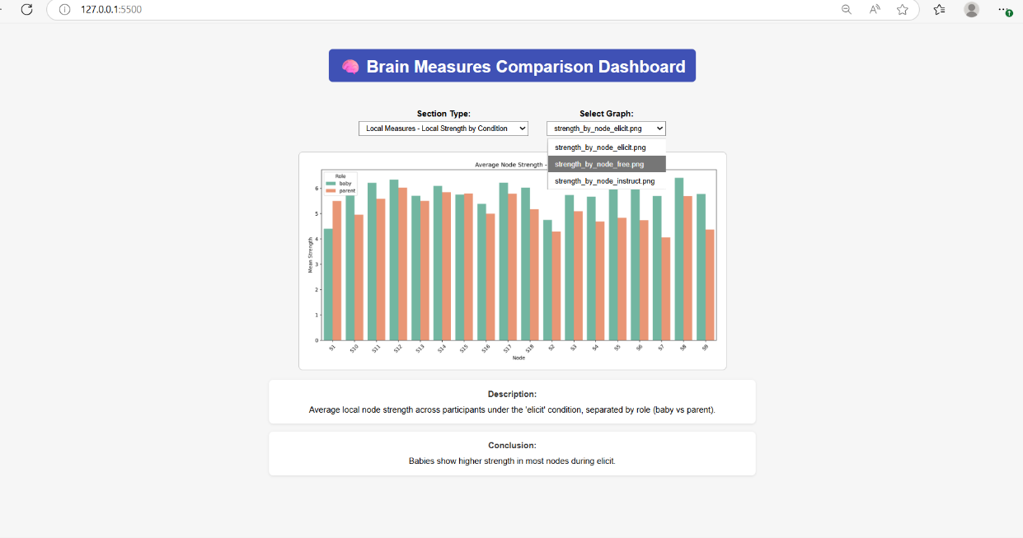

**How to Use:**

1. Open index.html in your browser.
2. Use the left dropdown to choose a section (e.g., “Local Strength by Condition”).
3. Use the right dropdown to pick a specific graph.
4. Read the auto-generated description and conclusion under the graph.
5. Repeat as needed to explore other metrics or views.

Maintenance Guide

**Purpose**

This guide is intended for future maintainers of the system. It provides essential information for updating, extending, or reinstalling the analysis pipeline after the project’s completion. It covers the operational environment, required libraries, system architecture, and practical tips for modifying components.

**System Environment**

Hardware Requirements

* Standard personal computer or workstation
* At least 8 GB RAM recommended for handling multiple dyad datasets
* Multi-core CPU recommended for permutation testing and bootstrapping

Operating System

Tested on: Windows 10 / Ubuntu 22.04 LTS

(Any OS with Python ≥ 3.8 should be compatible)

**Software Stack**

Programming Language

* Python 3.8+

Required Python Packages

**Install via:** pip install -r requirements.txt

**Or manually:** pip install numpy pandas scipy matplotlib plotly networkx seaborn

Note: For HTML generation, make sure Jupyter is installed (for notebook export), or use standalone HTML export tools.

**System Components and How to Maintain Them**

**1. Data Conversion and Preprocessing (Scripts/)**

* Scripts here transform .mat files into normalized .csv files.
* If fNIRS format changes (e.g., new number of channels), update parsing logic inside:
  + convert_mat_to_csv.py
  + clean_and_normalize_csv.py
* New signal types (e.g., HbR) can be added by modifying the field selection logic.

**2. Intra-brain Graph Analysis**

* Correlation threshold and significance settings are in:
  + intra_brain_connectivity.py (thresholds)
  + extract_intra_measures.py (metrics)
* To change thresholds (e.g., stricter r or p), update the corresponding if-condition.
* To add new metrics (e.g., betweenness), edit metric extraction block with:

import networkx as nx

nx.betweenness_centrality(G)

**3. Global Metric Comparisons (analysis/)**

* If new experimental conditions are introduced:
  + Add CSVs under the correct naming scheme (DyadID_Role_NewCondition.csv)
  + Duplicate and adapt scripts like compare_conditions.py to include the new condition
* You can add metrics to the bar plot output by expanding the metrics list in the script.

**4. Local Analysis (local_analysis/)**

* To compare more node-level properties (e.g., local efficiency), modify:
  + compare_strength_dyadic_difference.py
  + compare_strength_by_condition.py

**5. Visualization Dashboard**

* The index.html file can be updated manually or regenerated using Jupyter/nbconvert.
* To add new visualizations:
  + Save PNG/CSV into visualizations/ and tables/
  + Insert new <div> blocks and <iframe> references in the index.html accordingly

**Adding New Dyads or Conditions**

1. Save new .mat files under a consistent naming convention
2. Run the full pipeline:
   * Convert → Clean → Correlate → Extract metrics → Compare → Visualize
3. Append new PNGs/CSVs into visualizations/ and tables/
4. Update index.html if necessary

**Testing**

* Use simulated time-series in test_data/ (if available) for pipeline testing.
* Or create synthetic CSVs using numpy.random.randn(...) to test end-to-end behavior.

**Tips for Maintainability**

* Keep variable names consistent across scripts (especially for dyad ID, role, condition)
* Document all threshold changes inside the scripts for traceability
* Version control the project using git if planning further collaborative development
* When sharing: remove or anonymize any real participant data from .mat or .csv files

Technical Challenges and Solutions

Throughout the development of this project, we encountered several technical and analytical challenges, each addressed through tailored solutions grounded in both computational reasoning and neuroscientific validity.

**1. File Structure Inconsistencies and Naming Conventions**  
The raw .mat files provided to us included data for different dyads, roles (baby or parent), and conditions (free, elicit, instruct). However, file names were not fully standardized, containing occasional typos (e.g., “insrtuct” instead of “instruct”) and inconsistent labeling of participants. To ensure uniformity across the dataset, we implemented an automated filename normalization routine. This included correcting known misspellings, extracting role and condition information programmatically, and renaming files into a consistent format (dyadX_condition_role.csv). This preprocessing step was critical to avoid indexing errors and to automate the processing pipeline without manual intervention.

**2. Data Normalization Across Channels and Subjects**  
To make intra-brain comparisons across individuals meaningful, we standardized each signal using z-score normalization across time within each channel. This process removes inter-individual differences in signal magnitude and highlights temporal patterns of change, ensuring that correlation analyses are based on relative rather than absolute signal amplitude. This step was implemented immediately after converting the .mat recordings to .csv format, and it enabled reliable graph construction based on functional connectivity.

**3. Thresholding Correlation Matrices**  
After computing the Pearson correlation matrix between all 18 channels within each participant’s brain, we faced the challenge of distinguishing meaningful connections from noise. To address this, we applied a **dual-threshold criterion**: we retained only those connections for which the correlation magnitude was ≥ 0.3 and the associated p-value was ≤ 0.05. This ensured that only statistically significant and reasonably strong correlations were preserved in the adjacency matrix. This choice of threshold balances sensitivity and specificity and is consistent with thresholds used in prior functional connectivity studies.

**4. Graph Construction and Metric Computation**  
Once the thresholded correlation matrices were obtained, we converted them into undirected binary graphs using the NetworkX Python library. Although NetworkX provides built-in methods for calculating global metrics (e.g., degree, efficiency, modularity, clustering coefficient), interpreting these in a neuroscientific context required careful thought. We ensured that each graph was built with precisely 18 nodes (one per fNIRS channel) and verified that the metrics extracted (global and local) aligned with expected values from the literature. For example, we validated the small-worldness formula by checking that it reflected the ratio between clustering and path length, as commonly defined.

**5. Comparative Analysis Modules**  
Implementing comparisons across roles (baby vs. parent), conditions (free, elicit, instruct), and dyads required the design of modular scripts. One challenge was maintaining alignment between graph metrics and their respective metadata (dyad ID, role, condition) across multiple data frames. To manage this, we wrote custom functions that merged metric outputs with identifiers and grouped results by condition or role. These allowed automated generation of plots and tables for each comparison, including dyadic symmetry calculations and node-level strength differences.

**6. Visualization and Dashboard Integration**  
Creating an HTML-based dashboard that allowed non-programmers to explore the results interactively posed design and integration challenges. We developed a dynamic interface using HTML + embedded iframes to display graphs and tables. One issue was ensuring that each plot (e.g., global metrics by condition, local strength by node) would load correctly when selected from dropdowns. To resolve this, we standardized plot filenames and structured the folders (visualizations/, tables/) to match the dashboard logic. This made the dashboard accessible and useful for neuroscientific collaborators without technical expertise

Results and Conclusions

The developed system was applied to a dataset of parent–infant dyads, each recorded under three naturalistic social conditions (Free, Elicit, Instruct). The analysis focused on intra-brain functional connectivity, modeling each participant’s brain as a graph based on statistically significant correlations between fNIRS channels. Using graph-theoretic metrics, we observed consistent developmental trends: infants exhibited higher mean degree, clustering coefficient, and global efficiency, while parents demonstrated greater modularity- suggesting more segregated and functionally specialized networks in adults. These findings align with neurodevelopmental literature showing that early-stage brains tend to be more diffusely connected, with increasing modularization emerging through maturation [13], [14], [20]. The system successfully revealed condition- and role-specific network patterns and provided a reproducible pipeline for future studies.

Graph Topology and Centrality Insights  
The graph-theoretical analysis of intra-brain networks revealed important insights into the internal organization of parent and infant brain connectivity across social interaction conditions. Rather than showing uniform connectivity across all brain regions, certain nodes consistently exhibited higher functional strength. Specifically, infant brain networks showed elevated node strength in several channels, including S5, S7, and S9, which frequently emerged as locally dominant across all conditions—Free, Elicit, and Instruct. These nodes may reflect functionally important cortical regions that are broadly engaged during social contexts in early development.

This widespread connectivity pattern is consistent with known developmental characteristics of the infant brain, which tends to exhibit diffuse and non-specialized activity due to underdeveloped synaptic pruning and ongoing neural maturation [13], [14], [20]. By contrast, parent networks displayed more modest and selective node strength values, supporting the notion of a more refined and modular functional architecture in the mature brain.

Although anatomical mapping was not directly implemented in this project (i.e., no direct assignment of channels to cortical regions), the presence of strong connectivity in frontal-located channels (based on their likely position in standard fNIRS cap configurations) aligns with prior studies linking frontal cortex involvement to social and emotional engagement in infancy [11], [12].

Overall, the local node strength patterns support a developmental interpretation: infant brains appear to recruit broader networks during social interaction, while adult brains rely on more targeted and functionally specialized regions. This intra-brain asymmetry between roles (baby vs. parent) adds another layer to our understanding of how brain network organization evolves in early life.

Methodological Reflections

From a methodological perspective, the use of graph-theoretical modeling and thresholded Pearson correlations proved effective for analyzing intra-brain connectivity in parent–infant fNIRS data. Representing each brain as a network allowed for intuitive visual summaries that reduced the complexity of high-dimensional time-series data into interpretable graph structures. The decision to apply dual-thresholding - retaining only channel-to-channel correlations with absolute Pearson’s *r* ≥ 0.3 and statistical significance *p* ≤ 0.05 - served to emphasize strong, meaningful functional connections while filtering out noise. This approach aligns with best practices in hyperscanning studies aiming to focus on functionally relevant connections while minimizing spurious links caused by physiological or motion artifacts [1], [2], [8].

The extracted graphs enabled calculation of both global and local network metrics, providing a structured framework for comparison across dyads, roles, and interaction conditions. Metrics such as mean degree, modularity, and clustering coefficient helped characterize the organizational properties of each participant’s brain network [9], [10]. Importantly, the thresholding method was held consistent across participants, which supported fair comparisons and reproducible outcomes. While more advanced strategies such as adaptive thresholding or permutation-based null models were not implemented in this pipeline, the current method yielded stable, biologically interpretable results across all dyads. These design choices reflect a balance between analytical rigor and computational simplicity, making the pipeline accessible for further use in developmental hyperscanning research [5], [13].

Scientific Contributions

This project presents a reproducible and scientifically grounded framework for analyzing intra-brain connectivity in parent and infant participants, based on fNIRS hyperscanning data. By applying graph-theoretical metrics, the system enabled the quantification of both global and local features of functional brain organization across social interaction conditions (Free, Elicit, Instruct). Notably, the findings confirmed developmental trends observed in prior literature-such as higher mean degree and clustering in infants, and increased modularity in adults-consistent with known principles of neural maturation [11], [13], [14].

Methodologically, the system incorporated established techniques from network neuroscience, including dual-thresholded correlation matrices and standardized graph measures (e.g., efficiency, modularity), ensuring comparability and interpretability [1], [9], [10]. Each design decision - from correlation filtering to graph construction, was made with transparency and scientific justification, enhancing the pipeline’s credibility and future usability.

Looking forward, the system’s modular structure allows easy adaptation to other datasets or conditions, including longitudinal analyses or studies examining how intra-brain connectivity evolves with age or relates to cognitive or emotional development. As such, the framework offers a valuable contribution to the toolkit of developmental cognitive neuroscience [5], [13].

Lessons Learned

**What Worked Well:**

* Graph-theoretical analysis effectively transformed intra-brain correlations into interpretable network metrics (degree, efficiency, modularity), revealing parent–infant developmental differences [10], [11], [13].
* Python-based modular pipeline (conversion, normalization, graphing, visualization) enabled reproducibility, debugging, and clear result presentation (CSVs, plots, HTML dashboard).
* Flexible analysis structure supported comparisons by dyad, condition, and node, highlighting connectivity trends aligned with developmental neuroscience [5], [14].
* Dual-thresholding (|r| ≥ 0.3 and p ≤ 0.05) successfully filtered meaningful connections while reducing noise.

**What Could Be Improved:**

* Signal preprocessing was outside our scope due to preprocessed input data. Future work should incorporate motion correction and short-separation channels to address noise sources [1], [4].
* Only intra-brain connectivity was analyzed. Future studies could explore inter-brain synchrony and developmental links [6], [21].
* Fixed thresholding worked but could be enhanced by adaptive methods like FDR or proportional thresholding [14].
* Limited metrics: Adding measures like path length, betweenness, or assortativity could enrich findings [13], [15].
* Scalability beyond 19 dyads remains untested; future use should assess performance on larger datasets with batch controls.
* Interdisciplinary communication was critical. Translating technical terms into accessible language improved collaboration and interpretation.

Success Metrics and Evaluation

To evaluate the project’s success, we defined a set of measurable goals at the outset. These were grounded in analytical clarity, consistency, usability, and relevance to developmental neuroscience.

1. **Analytical Validity** – The system successfully distinguished between interaction conditions and participant roles. Graph-theoretical metrics such as mean degree, global efficiency, and modularity showed consistent differences between infants and parents across conditions. For example, infants exhibited higher mean degree and efficiency, while parents exhibited higher modularity—reflecting more segregated networks. These findings align with prior developmental literature suggesting higher connectivity density in early life and increasing specialization with age [11], [13], [14].
2. **Reproducibility** – The entire pipeline was modular and deterministic. Each script produced consistent outputs across runs, and changes in data (e.g., correcting filenames or adding dyads) propagated smoothly. This reproducibility was essential in comparing dozens of dyads across conditions and roles.
3. **Interpretability** – The generated HTML dashboard proved effective in visualizing and interpreting results. Users could explore summary plots, hover over tables, and switch between dyads and conditions without code interaction. This supported intuitive access to complex findings and simplified communication with supervising researchers.
4. **Computational Simplicity with Scientific Rigor** – While we did not implement complex null-hypothesis testing or random pair permutation tests, the use of dual-thresholded Pearson correlations (|r| ≥ 0.3 and p ≤ 0.05) served to filter out noise while retaining biologically plausible connections. This decision reflected a balance between statistical filtering and interpretability, consistent with recent fNIRS intra-brain connectivity work [2], [9].

While our system did not formally link brain network metrics with behavioral outcomes, the observed patterns of increased infant connectivity under certain conditions (e.g., elicited interaction) suggest future opportunities to relate network topology with developmental markers or social behavior.

In summary, the system achieved its primary goals: extracting meaningful intra-brain connectivity patterns, supporting reliable cross-dyad comparisons, and enabling reproducible graph-based exploration of fNIRS data. These outcomes make it a solid foundation for further research into parent–infant brain dynamics.

**References**

1. Oku, A. Y. A., Barreto, C., Bruneri, G. A., Brockington, G., Fujita, A., & Sato, J. R. (2022). Applications of graph theory to the analysis of fNIRS data in hyperscanning paradigms. *Frontiers in Computational Neuroscience, 16*, 975743. <https://doi.org/10.3389/fncom.2022.975743>
2. do Nascimento, D. C., Santos da Silva, J. R., Ara, A., Sato, J. R., & Costa, L. (2023). Hyperscanning fNIRS data analysis using multiregression dynamic models: An illustration in a violin duo. *Frontiers in Computational Neuroscience, 17*, 1132160. <https://doi.org/10.3389/fncom.2023.1132160>
3. Barreto, C., Bruneri, G. A., Brockington, G., Ayaz, H., & Sato, J. R. (2021). A new statistical approach for fNIRS hyperscanning to predict brain activity of preschoolers using teacher’s brain data. *Frontiers in Human Neuroscience, 15*, 622146. <https://doi.org/10.3389/fnhum.2021.622146>
4. Nguyen, T., Hoehl, S., & Vrtička, P. (2021). A guide to parent–child fNIRS hyperscanning data processing and analysis. *Sensors, 21*(12), 4075. <https://doi.org/10.3390/s21124075>
5. Piazza, E., Hasenfratz, V., Boccadoro, S., et al. (2020). Investigating mother–child neural synchrony in naturalistic settings: A fNIRS hyperscanning study. *Developmental Cognitive Neuroscience, 45*, 100863. <https://doi.org/10.1016/j.dcn.2020.100863>
6. Reindl, E., Gerloff, L., Scharke, S., & Hoehl, S. (2018). Interactional synchrony in the infant brain: A near-infrared spectroscopy study. *Brain and Development, 40*(2), 141–150. <https://doi.org/10.1016/j.braindev.2017.10.003>
7. Santamaria, N., do Nascimento, D. C., et al. (2022). Parenting links to parent–child interbrain synchrony: A real-time fNIRS study. *Social Cognitive and Affective Neuroscience, 17*(1), 45–57. <https://doi.org/10.1093/scan/nsab125>
8. Czeszumski, M., Eustergerling, A., et al. (2020). Hyperscanning: A valid method to study neural inter-brain underpinnings of social interaction. *Frontiers in Human Neuroscience, 14*, 39. <https://doi.org/10.3389/fnhum.2020.00039>
9. Bullmore, E., & Sporns, O. (2012). The economy of brain network organization. Nature Reviews Neuroscience, 13(5), 336–349. <https://doi.org/10.1038/nrn3214>
10. Watts, D. J., & Strogatz, S. H. (1998). Collective dynamics of ‘small-world’ networks. Nature, 393(6684), 440–442. <https://doi.org/10.1038/30918>
11. Fransson, P., Aden, U., Blennow, M., & Lagercrantz, H. (2011). The functional architecture of the infant brain as revealed by resting-state fMRI. Cerebral Cortex, 21(1), 145–154. <https://doi.org/10.1093/cercor/bhq071>
12. van den Heuvel, M. P., Kersbergen, K. J., de Reus, M. A., Keunen, K., Kahn, R. S., Groenendaal, F., de Vries, L. S., & Benders, M. J. (2015). The neonatal connectome during preterm brain development. Cerebral Cortex, 25(9), 3000–3013. <https://doi.org/10.1093/cercor/bhu095>
13. Cao, M., Huang, H., He, Y. (2017). Developmental connectomics from infancy through early childhood. Trends in Neurosciences, 40(8), 494–506. <https://doi.org/10.1016/j.tins.2017.06.003>
14. Chen, Y., & Deem, M. W. (2015). Development of modularity in the neural activity of children. PLoS Computational Biology, 11(4), e1004090. <https://doi.org/10.1371/journal.pcbi.1004090>
15. Rubinov, M., & Sporns, O. (2010). Complex network measures of brain connectivity: Uses and interpretations. NeuroImage, 52(3), 1059–1069. <https://doi.org/10.1016/j.neuroimage.2009.10.003>
16. De Asis-Cruz, J., Bouyssi-Kobar, M., Evangelou, I., Vezina, G., Robertson, R. L., & du Plessis, A. J. (2016). Functional properties of resting state networks in healthy full-term newborns. Scientific Reports, 5, 17755. <https://doi.org/10.1038/srep17755>
17. Park, M., Chung, J., Kim, J. K., Jeong, Y., & Moon, W. J. (2019). Altered functional brain networks in patients with traumatic anosmia: Resting-state fMRI based on graph theoretical analysis. Korean Journal of Radiology, 20(11), 1536–1545. <https://doi.org/10.3348/kjr.2019.0104>
18. ] Rotem-Kohavi, N., Hilderman, C. G. E., Liu, A., Makan, N., Wang, J. Z., & Virji-Babul, N. (2014). Network analysis of perception–action coupling in infants. Frontiers in Human Neuroscience, 8, 209. <https://doi.org/10.3389/fnhum.2014.00209>
19. Joseph, J. E., Gathers, A. D., & Bhatt, R. S. (2011). Progressive and regressive developmental changes in neural substrates for face processing: Testing specific predictions of the Interactive Specialization account. Developmental Science, 14(2), 227–241. <https://doi.org/10.1111/j.1467-7687.2010.00963.x>
20. Spencer-Smith, M., & Anderson, V. (2009). Healthy and abnormal development of the prefrontal cortex. *Developmental Neurorehabilitation*, 12(5), 279–297. <https://doi.org/10.1080/17518420903090701>
21. Roche, E. C., Redcay, E., & Romeo, R. R. (2025). Caregiver–child neural synchrony: Magic, mirage, or developmental mechanism? Developmental Cognitive Neuroscience, 71, 101482. <https://doi.org/10.1016/j.dcn.2024.101482>